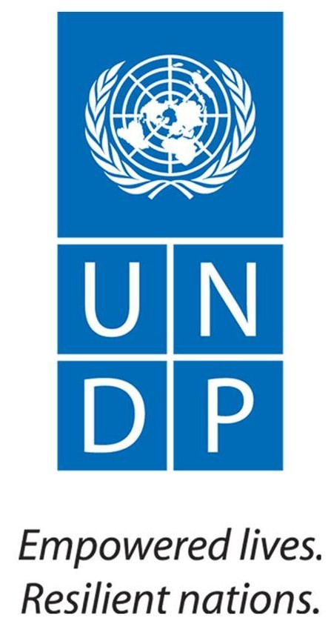 | Back to Office Report  Kick start the implementation of the Institutional Strengthening of the Forest Sector Development Program in Ethiopia
 |  | Mission Date: August 06-14/2015
I. Background :  The five years program on Institutional Strengthening for the Sector Development in Ethiopia has been developed and signed by UNDP and government and its implementation commenced. The overall objective of this program is to strengthen government capacity in the forest sector at all levels and spearhead the implementation of the forestry component contained in the GTP and CRGE Strategy.  The Specific objectives of the program are to:  - Foster institutional strengthening at all levels;  - Enhance and stimulate sustainable forest development in line with GTP and CRGE  - promote popular participation;  - Strengthen Science and Innovation and  - Promote private sector engagement.  The five major pillars of the project are: Institutional development; Forest development; Private sector involvement; Stakeholder engagement and Science and Innovation.  II Mission Objectives  The objectives of the Mission are to:  - Discuss with the relevant bureaus and offices of the regional presidents in Amhara and Tigray regional states on the organizational arrangement of the program implementation  - Discuss with the regional and district relevant bureaus and select districts and specific sites( for short rotation plantation and rehabilitation) where the forest conservation and development for their multiple benefits component of the program is implemented  - Assess the urgent capacity needs in terms of skilled human resources, IT , equipment and furniture of forest conservation and development relevant offices in the regions;  - Discuss with the district administration on the establishment of project management offices/forest offices and agree on how to full fill with the required staff equipment and materials ;  - Select sites for the establishment of new forest nurseries OR make use of the existing nurseries within the project woredas and strategize on how to fulfil the nursery equipment and material for seedling production.  - Discuss and agree on the establishment of MEF replica in the regions  III. Participants of the Mission  Tefera Mengistu (PhD), Adviser to the State Minister, MEF  Ababu Anage , National Climate Change Specialist, UNDP;  IV. Main activities undertaken  presentation and discussion for regional, zonal and district levels decision makers  The mission made presentation on the over view of the program; selection criteria of the districts for program implementation; distribution of project / forest offices in the three regions and architecture of program implementation.  The main outcomes of the regional , zonal and district levels discussions in Amara and Tigray Regional states are discussed here under;  Amhara and Tigray National Regional States  Detail discussion being held with decision makers at regional, zonal and district levels. The list of contacted persons are attached here with.  The major outcomes of the discussion are:  - The suggested four districts by the president of the region have been endorsed by all stake holders;  - The Mission received official letter on the selection of the four district in Amhara (Mekit, Wadla, Dessie Zuria , Delanta );  - The Mission visited Maychew, Embalage Addishu and Korem districts in Tigray region and proposed Embalage and Maychew for the program implementation;  - Consensus reached on the relevance program implementation for the attainment of the GTP targets of the region;  - The district administrators and Environmental Protection and Land Use Administration heads/ representatives have agreed to avail 1200 ha of land /district for the establishment of fast growing plantations;  - Similar agreements reached to allocate 15,000-16,000 ha of land /district for rehabilitations and to undertake other supportive activities such as honey production; fruit trees introduction, etc. in the closed areas;  - All the district administrators have agreed to spear head the program implementation. The district administrator will chair the Steering Committee as well; |  | - Agreement reached to deploy group of experts within two weeks to go to the sites for verification  - Agreement reached to do every effort to quickly start the nursery activities and commence raising of seed lings for 2016 plantation  - Consensus reached that District forest officers in collaboration with regional experts to do full inventory of the available and missing materials and equipment and communicate to MEF.  - Based on the information received from the regions MEF agreed procure the missing items and transport to each district  - The organized local communities will be provided with land entitlement, right to manage, own and benefited from the products of the plantations. MEF, UNDP and other relevant bureaus and entities will provide full technical support on scientific man made forest mnagmmnent and market linkages.  - Agreement reached that the 4800 ha plantations with fast growing tree species will be managed by community forestry approach;  - The Mission has visited the proposed plantation sites in Mekit, Debermakos zuria Wadla from Amahra and Korum, Maychew and Embalaje districts from Tigray  - The Missions accepted the sites by analyzing the basic requirements for the establishment of plantation such as : accessibility; presence of existing nursery or possibility of establishing new nursery; local community willingness and commitment, etc  V. Challenges and Constraints  - Delay in the decision of the government to establish the regional bureaus in the regions;  - The existence of forestry activities in scattered manner within the directorates of BoA  - Un healthy relationship between Amhara Forest Enterprise and Bureau of Agriculture of the region and absence of managing and coordination of forest activities in one institution. Forest extension and protection is in the BoA while the utilization and marketing is within the enterprise  VI. The Way Forward  - Deploy group of experts by MEF within two weeks to the plantation sites for detail analysis and verification including species selection ; demarcation and mapping  - Identify and communicate the missing items of nurseries and communicate MEF within two weeks’ time  - Based on the information from regions MEF procure nursery materials and equipment by short listing procurement approach and transport to districts by 2nd week of September/2015  - To accelerate recruitment of project personnel at district and feral level MEF is required to advertise the posts early next week: (August 17/18) on federal and regional newspapers;  - All project personnel should be on board to the latest 2nd week of September/2105;  - MEF to write official letter for the Tigray National Regional State president office about the program;  - Organize field trip to SNNPRS immediately to undertake similar activities
Reported by: Ababu Anage, National Climate Change Specialist
Dr. Tefera Mengistu, Advisor to the State Minister

